# Power BI

Demo

Why?

What –

BI – B- Business and I – Intelligence

I –

MSBI

Power BI

Big Data and Bigger Data

3V

Google Trends

Gartner Report

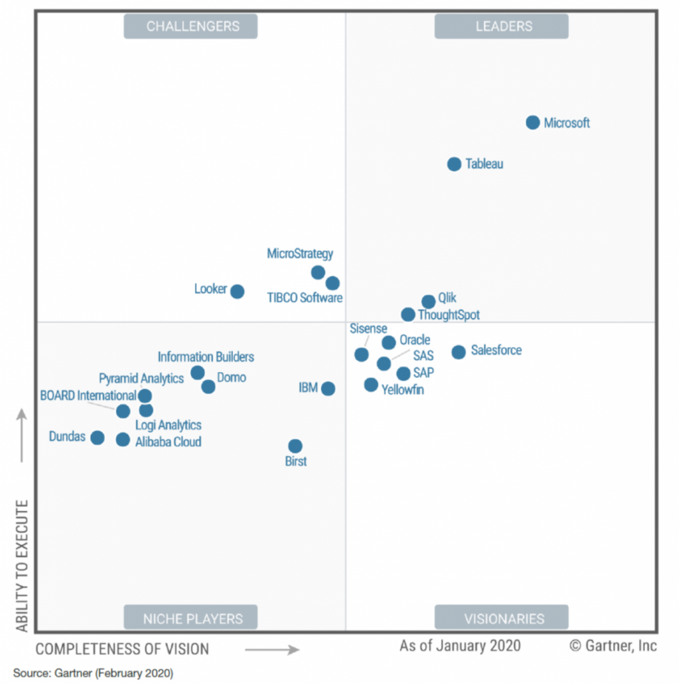

Who – Am I

When –

7 AM to 8 AM – Class

Mon – Saturday

Clarification session on 1 on 1

Assignments

Recording

Real-Time Scenarios

Interview Preparations

Service Account 5000$ for 2 months

Daily Status Call –

What you have done yesterday

What are you planning for today

Will you do tomorrow

Are there any Obstacles?

Power BI

Power BI Desktop – Free

Power BI Service Account – License

Download/Install the PBI Desktop

## RDLS vs SDLC

## Report – IMF GDP Report

Source Type: Web

# Population Report

|  |  |  |  |
| --- | --- | --- | --- |
| Feature | MSBI - 10 | Power BI - 2 | Excel BI |
| ETL | SSIS 5 | Power Query | Power Query |
| Modeling | SSAS 3 | Modelling | Power Pivot |
| Report | SSRS 2 | Visualization | Power View |

Append-POC

Rule-1 Structure should be Same

R2 – Data Type is not a matter

R3 – Add null if there is no column available

# DWH

## Conceptual Diagram

Entities will be created

## Logical Diagram

Relationship will be created b/n entities.

## Physical Diagram

Based On Software

## Table Types:

### Dimension Table

Wh

What

Where

When

Who

~~Why~~

Types of Dim Table

### Fact Table

Foreign keys

How Much

How Many

Type of Fact

## Schema

Star

Direct relationship between fact and Dim

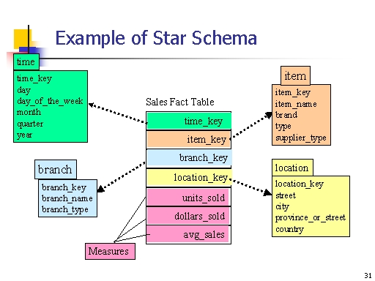

Snowflake

In-Direct relationship between fact and Dim

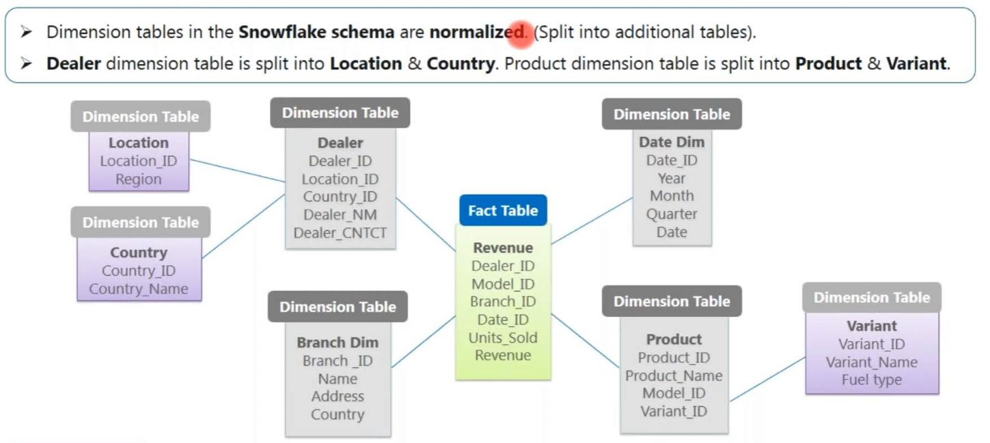

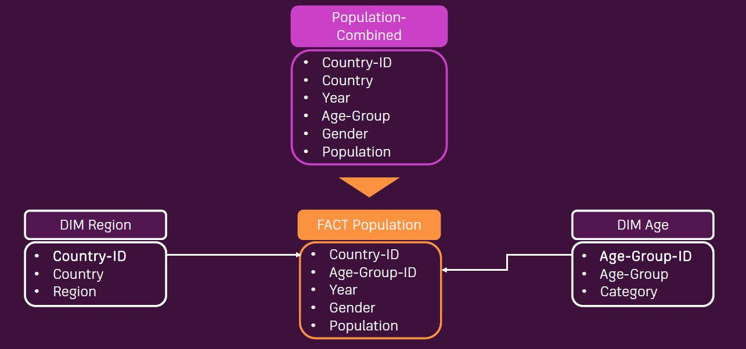

## Unpiviot vs Pivot

POC with all possible cases.

File – 1 208950

File – 2 208950

File – 3 213129

Total recs = 631029

631029

## Merge

Join Kinds

Append Vs Merge

|  |  |  |
| --- | --- | --- |
| Feature | Append | Merge |
| More than 2 tables | Yes | No |
| Table size | It will be taller  No. of records will be increased.  SQL union ALL | Fatter  No. of columns will be increased. |
| Data Type | Not a matter | Yes – it should match |
| Column Names | Yes | No |
|  |  | 6 Join kinds  LO RO FO LA RA Inner |

## Duplicate vs Reference

## Enter data

Performance Improvement in Power Query

Before Loading to PBI Desktop



After Loading to PBI Desktop



After Performance improvement



Power BI Service

Cloud SAAS Application – common url – app.powerbi.com

My workspace – free but not free

License

Pro

Premium

PPC – P1/P2/P3/P4

PPU -

Embedded

Create Work space

## Roles

O365 Admin

Tenant Admin

Admin – Workspace

Member

Contributor

Viewer

# Modelling

## Cars Report

Cardinality/ Relationship Type: 1-M/M-1/1-1/M-M

Bridge Table

Cross filtering: Single/Both

Active or Inactive Relationships

Activate Inactive Relationship with UseRelationship DAX function

Why Inactive relationship?

How to avoid Inactive relationship?

# Visualizations

## ExcelData Report

## Table

How to do assignments?

ONLY Columns

Aggregate functions.

Edit Interactions

Formatting

Conditional formatting

Background color/Data Bars/Font color/url/icons

Real Time Scenario.

## Matrix

Rows, Columns, Values.

Stepped Layout ON vs OFF

Stepped Layout is Realtime scenario

Conditional formatting

Background color/Data Bars/Font color/url/icons

Drill down vs Drill through

Drill UP

Drill ON

Go to Next Level in the Hierarchy

Expand Hierarchy

Hierarchy:

System Defined. Date

Visual Defined.

User Defined.

## Card vs Multi Row vs KPI

## Column vs Bar Chart

As user, I would like to see, Channel by Sales. – Bar Chart

As user, I would like to see, Sales by Channel – Column Chart

Stacked vs Cluster vs Small Multiples

Hierarchy

Analytics

Avg

Constant

## Ribbon – (RR) Rank

## Slicer Vs Filter

Slicer (TNDSH)

### T- Text

List vs Dropping – List can be converted into Horizontal

Radio/ Select ALL/multi-Select

**Search**/export/sort

Export data – Assignment – for All Visual

### N – Number

List vs DropDown vs Between vs LT vs GT

List vs Dropping – List can be converted into Horizontal

Radio/ Select ALL/multi-Select

export/sort/Eraser

### D – Date

Realtime Challenge to change from DDMMYYYY to MMDDYYYY

Regional setting

Machine Region for date

Relative Date vs Relative Time Vs Between Vs Before vs After

Calendar Week vs Week

### S – Sync

### H – Hierarchical Slicer

## Filters

VPADE

V- Visual Level Filter – Basic vs Advance vs **TopN**

P – Page

A – All Page

D – Drill thru

E – Edit Interaction

## Line/Area/Stacked Area Chart

Trend Analysis

## Pie/Donut Chart

## Waterfall chart

## Funnel Chart

# SQL Server

SQL – Structure Query Language

Bigdata / Bigger data

3V – Volume, Variety, Velocity

Unstructured

Semi-Semi structured

Structure

OLTP vs OLAP

|  |  |  |
| --- | --- | --- |
| Feature | OLTP | OLAP(DWH) |
|  | Online Transactional Processing | Online Analytical Processing |
| Operations | CRUD  C – Create  R – Read  U – Update  D - Delete | R – Read |
| Table Size | Small | Big |
|  | Lot of joins | Less joins |

## W3 school

Download and installation

<https://www.microsoft.com/en-in/sql-server/sql-server-downloads>

Attaching the Readymade warehouse

<https://learn.microsoft.com/en-us/sql/samples/adventureworks-install-configure?view=sql-server-ver16&tabs=ssms>

Databases

Tables

Views

StoreProc

Joins

## Connections

Import

Tables

SQL Statements

Views

Store Proc

Direct

Meta data – data about the data

Tables

Views

Store Proc

SQL Statements

Composite

Tables

Views

Store Proc

SQL Statements

|  |  |  |
| --- | --- | --- |
| Feature | Import | Direct Query |
| Data | Data and meta data import into pbix file | ONLY meta data is imported  But data will not be imported |
| Size | Up to 10 GB | There is no limit |
| Connection change | Cannt convert import to direct | Yes, We can convert easily from Direct to Import |
| Performance | Very good | Not that great. It depends on many factors |
| Best sources from SQL Server | View, Tables | View and Tables |

## Performance improvement techniques

Source

IF SQL Server

It should Configuration

Its not too busy with other query

Materialized view

Power Query

Native Query/Query folding – ON

Enable Load - off

Modelling

m-m

bidirectional cross filter

snowflake schema

Visualization

Performance Analyzer

Edit Interaction

Service

Other techniques

Live?